Programming with Python & Problem Solving (05MC0107)
Lab Manual (2026-27)
Program: MCA
Semester: 1
Name of the Student: HEET POPAT
Enrolment No.: 92600584084

INDEX

Lab | Program | Date | Remarks | Signature
1 | Write a program to demonstrate basic input and output operations in python.
2 | Write a program to illustrate the use of different data types and type casting.
3 | Write a program to perform arithmetic, relational and logical operations using Python operators.
4 | Write a program to demonstrate string operations including slicing, formatting and built-in string functions.
5 | Write a program to create and manipulate lists using indexing, slicing and list comprehensions.
6 | Write a program to illustrate the use of tuples and sets with basic operations.
7 | Write a program to create a dictionary and demonstrate dictionary methods and iteration.
8 | Write a program to explain mutable and immutable objects in Python.
9 | Write a program to define and use user-defined functions with different types of arguments.
10 | Write a program to demonstrate recursion using factorial or Fibonacci series.
11 | Write a program to demonstrate conditional statements using if, if-else, and if-elif-else.
12 | Write a program to check whether a number is positive, negative, or zero using nested conditions.
13 | Write a program to generate a multiplication table using a for loop.
14 | Write a program to find the sum of digits of a number using a while loop.
15 | Write a program to demonstrate the use of break, continue, and pass statements.
16 | Write a program to iterate over lists, strings, and dictionaries using loops.
17 | Write a program to demonstrate list, dictionary, and set comprehensions.
18 | Write a program to illustrate variable scope using local, global, and nonlocal variables.
19 | Write a program to demonstrate iterators and iterables in Python.
20 | Write a program to generate a sequence of numbers using generator functions and the yield keyword.
21
22
23
24
25
26
27
28
29
30
31
32
33
34
35
36

Q1

Definition:
Write a program to demonstrate basic input and output operations in Python.

Aim/Objective:
To write and execute a Python program that demonstrates basic input and output operations using input() and print() functions.
Source Code:
"""Program 01 :- Write a program to demonstrate basic input and output operations in python."""

name = input("Enter your name: ")
age = input("Enter your age: ")

print("\nHello,", name)
print("Your age is", age)

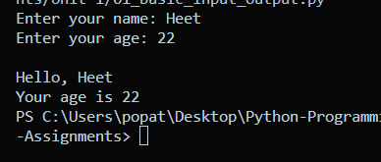

Conclusion:
Thus, the Python program was successfully executed to demonstrate basic input and output operations. The input() function was used to accept data from the user, while the print() function was used to display the output.

Q2

Definition:
Write a program to illustrate the use of different data types and type casting.

Aim/Objective:
To write and execute a Python program that demonstrates the use of different data types and type casting.

Source Code:
"""Program 02:- Write a Program to demonstrate different data types and type casting """
integer_value = 25
float_value = 10.5
string_value = "50"
boolean_value = True

print("Integer value: ",integer_value)
print("Float Value: ", float_value)
print("String Value: ", string_value)
print("Boolean Value: ",boolean_value)

converted_integer = int(string_value)
converted_float = float(integer_value)
converted_string = str(integer_value)

print("\nAfter Type Casting: ")
print("String to Integer:", converted_integer)
print("Integer to Float:",converted_float)
print("Integer to String:",converted_string)

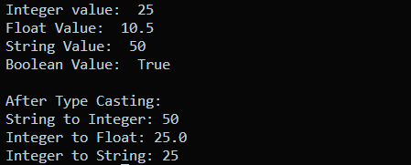

Conclusion:
Thus, the Python program was successfully executed to demonstrate different data types and type casting. The program showed how values can be stored using different data types and converted from one type to another using functions such as int(), float(), and str().

Q3

Definition:
Write a program to perform arithmetic, relational and logical operations using Python operators.

Aim/Objective:
To write and execute a Python program to demonstrate arithmetic, relational, and logical operations using Python operators.

Source Code:
""" Write a program to perform arithmetic relational and logical operations using python operators. """

a = 10
b = 5

print("Arithmetic Operations:")
print("Addition:",a+b)
print("Subtraction:",a-b)
print("Multiplication:",a*b)
print("Division:",a/b)
print("Modulus:",a%b)
print("Exponentiation:",a**b)
print("Floor Division:",a//b)

print("\n Relational Operations:")
print("a == b", a == b)
print("a != b", a != b)
print("a > b:", a > b)
print("a < b:", a < b)
print("a >= b:", a >= b)
print("a <= b:", a <= b)

x = True
y = False

print("\n Logical Operations:")
print("x and y:", a and y)
print("x or y:", x or y)
print("not x:", not x)

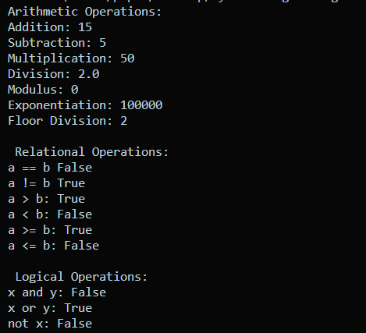

Conclusion:
Thus, the Python program was successfully executed to demonstrate arithmetic, relational, and logical operations. Arithmetic operators were used for mathematical calculations, relational operators were used to compare values, and logical operators were used to combine or evaluate conditions.

Q4

Definition:
Write a program to demonstrate string operations including slicing, formatting and built-in string functions.

Aim/Objective:
To write and execute a Python program to demonstrate string slicing, string formatting, and built-in string functions in Python.

Source Code:
""" Write a program to demonstrate string operations including slicing formatting and build-in string functions. """

text = "Python Programming"

#string slicing
print("Original String:",text)
print("First 6 Characters:",text[:6])
print("Characters from index 7:",text[7:])
print("Characters from index 0 to 5:",text[0:6])

#string formatting
name = "Heet"
language = "Python"
age = 21
city = "Rajkot"

print("\nString Formatting:")
print("My name is {} and I am learning {}.".format(name, language))
print("\n I am Learning {} because ahead i want to contribute in ai ml project in gsoc".format(language))
print("\n I am {} years old and i live in {}".format(age,city))

#Build-in string functions
print("\nBuild-in String Functions:")
print("Length:",len(text))
print("Uppercase:",text.upper())
print("Lowercase:",text.lower())
print("Replace:",text.replace("Python","Java"))
print("Find 'Programming':", text.find("Programming"))
print("Count of 'm':",text.count("m"))
print("count of 'p':",text.count("p"))

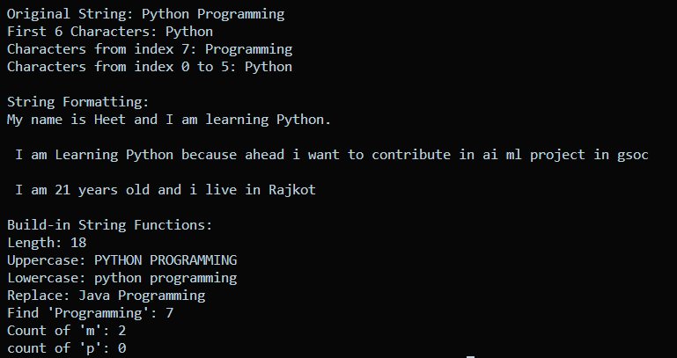

Conclusion:
Thus, the Python program was successfully executed to demonstrate string slicing, string formatting, and built-in string functions. These operations help in extracting, formatting, modifying, and analyzing text efficiently in Python.

Q5

Definition:
Write a program to create and manipulate lists using indexing, slicing, and list comprehensions.

Aim/Objective:
To write and execute a Python program to create and manipulate lists using indexing, slicing, and list comprehensions.

Source Code:
""" Write a program to create and manipulate lists using indexing slicing and list comprehensions. """

numbers = [10,20,30,40,50]

print("Original List: ",numbers)

#inexing
print("\nIndexing:")
print("First element:",numbers[0])
print("Third element:",numbers[2])
print("Last element:",numbers[-1])

#slicing
print("\nSlicing:")
print("First three elements:",numbers[:3])
print("Elements from index 2: ",numbers[2:])
print("Elements from index 1 to 3:",numbers[1:4])

#Manipulating the list
numbers.append(60)
numbers.remove(20)

print("\nAfter Manipulation:")
print("List:",numbers)

squares = [i ** 2 for i in numbers]

print("\nList Comprehension:")
print("Squares:",squares)

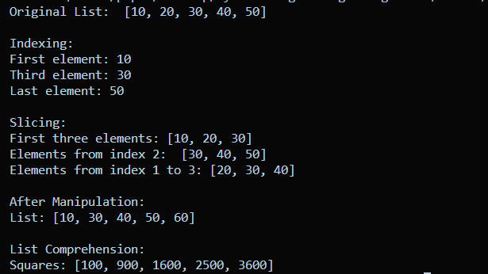

Conclusion:
Thus, the Python program was successfully executed to demonstrate the creation and manipulation of lists using indexing, slicing, and list comprehension. Indexing was used to access individual elements, slicing was used to access a range of elements, and list comprehension was used to efficiently create a new list.

Q6

Definition:
Write a program to illustrate the use of tuples and sets with basic operations.

Aim/Objective:
To write and execute a Python program to demonstrate the use of tuples and sets with basic operations.

Source Code:
""" To write and execute a Python program to demonstrate the use of tuples and sets with basic operations. """

numbers = (10,20,30,40,50)

print("Tuple:",numbers)

print("\n Tuple Operations:")
print("First element:",numbers[0])
print("Last element:",numbers[-1])
print("Length of tuple:",len(numbers))

print("Tuple slicing:",numbers[1:4])

set1 = {10,20,30,40}
set2 = {30,40,50,60}

print("\nSet Operations:")
print("Set 1:",set1)
print("Set 2:",set2)

set1.add(70)
print("After adding 70:",set1)

set1.remove(20)
print("After removing 20:",set1)

print("Union:",set1.union(set2))

print("Intersection:",set1.intersection(set2))

print("Difference:",set1.difference(set2))

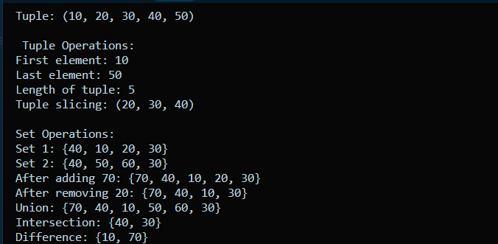

Conclusion:
Thus, the Python program was successfully executed to demonstrate tuples and sets with basic operations. Tuple indexing, slicing, and length operations were performed, while set operations such as adding, removing, union, intersection, and difference were demonstrated.

Q7

Definition:
Write a program to create a dictionary and demonstrate dictionary methods and iteration.

Aim/Objective:
To write and execute a Python program to create a dictionary and demonstrate various dictionary methods and iteration.

Source Code:
""" Program to demonstrate dictionary methods and iteration """

student = {
"name": "Heet",
"age": 22,
"course": "MCA"
}

print("Original Dictionary:", student)

print("\nName:", student["name"])

student["city"] = "Ahmedabad"

student["age"] = 23

print("\nAfter Adding and Updating:")
print(student)

# Dictionary methods
print("\nDictionary Methods:")
print("Keys:", student.keys())
print("Values:", student.values())
print("Items:", student.items())

student.pop("city")

print("\nAfter Removing City:")
print(student)

print("\nDictionary Iteration:")
for key, value in student.items():
print(key, ":", value)

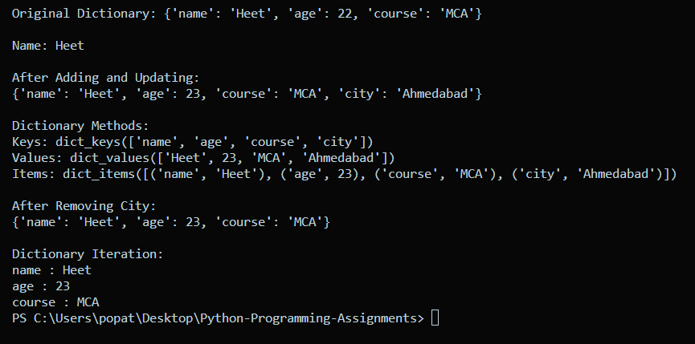

Conclusion:
Thus, the Python program was successfully executed to demonstrate the creation of a dictionary, various dictionary methods, and iteration through key-value pairs. Dictionaries are useful for storing and accessing data using unique keys.

Q8

Definition:
Write a program to explain mutable and immutable objects in Python.

Aim/Objective:
To write and execute a Python program to demonstrate the difference between mutable and immutable objects in Python.

Source Code:
""" Program to demonstrate mutable and immutable objects """

numbers = [10, 20, 30]

print("Original List:", numbers)

numbers[0] = 100

print("Modified List:", numbers)

number = 10

print("\nOriginal Integer:", number)

number = number + 5

print("Modified Integer:", number)

name = "Python"

print("\nOriginal String:", name)

name = name + " Programming"

print("Modified String:", name)

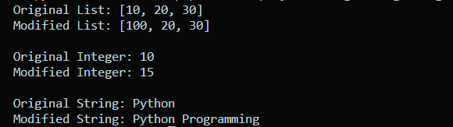

Conclusion:
Thus, the Python program was successfully executed to demonstrate mutable and immutable objects. The list was modified directly because lists are mutable, whereas integer and string values cannot be changed directly because they are immutable.

Q9

Definition:
Write a program to define and use user-defined functions with different types of arguments.

Aim/Objective:
To write and execute a Python program to demonstrate user-defined functions using different types of arguments such as positional, default, keyword, and variable-length arguments.

Source Code:
""" Program to demonstrate user-defined functionswith different types of arguments """

def add(a, b):
return a + b

print("Addition:", add(10, 20))

def greet(name="Student"):
print("Hello,", name)

greet()
greet("Heet")

def student_info(name, age):
print("Name:", name)
print("Age:", age)

student_info(age=22, name="Heet")

def total(*numbers):
return sum(numbers)

print("Total:", total(10, 20, 30, 40))

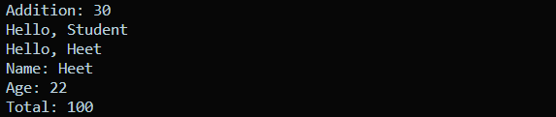

Conclusion:
Thus, the Python program was successfully executed to demonstrate user-defined functions with different types of arguments. Positional arguments, default arguments, keyword arguments, and variable-length arguments were used to make functions flexible and reusable.

Q10

Q10(a) Factorial Using Recursion

Definition:
Write a program to demonstrate recursion using factorial.

Aim/Objective:
To write and execute a Python program to calculate the factorial of a number using recursion.
Source Code:
""" Program to demonstrate recursion using factorial """

def factorial(n):
if n == 0 or n == 1:
return 1
else:
return n * factorial(n - 1)

number = 5

result = factorial(number)

print("Number:", number)
print("Factorial:", result)

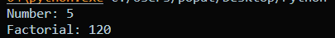

Conclusion:
Thus, the Python program was successfully executed to calculate the factorial of a number using recursion. The function repeatedly calls itself with a smaller value until it reaches the base condition of 0 or 1, after which the results are returned.

Q10(b) Fibonacci Series Using Recursion

Definition:
Write a program to demonstrate recursion using the Fibonacci series.

Aim/Objective:
To write and execute a Python program to generate the Fibonacci series using recursion.

Source Code:
""" Program to demonstrate recursion using Fibonacci series """

def fibonacci(n):
if n <= 1:
return n
else:
return fibonacci(n - 1) + fibonacci(n - 2)

terms = 7

print("Fibonacci Series:")

for i in range(terms):
print(fibonacci(i), end=" ")

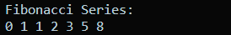

Conclusion:
Thus, the Python program was successfully executed to generate the Fibonacci series using recursion. The function calls itself with the previous two positions, and the base condition returns the first two Fibonacci values, 0 and 1.

UNIT 2

Q1. Conditional Statements

Definition:

Conditional statements are used to execute different blocks of code depending on whether a condition is true or false. Python provides if, if-else, and if-elif-else statements for decision making.

Aim/Objective:
To write and execute a Python program demonstrating if, if-else, and if-elif-else conditional statements.

Source Code:
"""Program to demonstrate conditional statements"""

# if statement
age = 20

if age >= 18:
print("You are eligible to vote.")

# if-else statement
number = 10

if number % 2 == 0:
print("Number is even.")
else:
print("Number is odd.")

# if-elif-else statement
marks = 75

if marks >= 90:
print("Grade A+")
elif marks >= 75:
print("Grade A")
elif marks >= 60:
print("Grade B")
else:
print("Grade C")

Conclusion:
Thus, the Python program was successfully executed to demonstrate if, if-else, and if-elif-else conditional statements for decision making.

Q2. Positive, Negative or Zero Using Nested Conditions

Definition:
Nested conditions are conditional statements placed inside another conditional statement. They are useful when a second decision needs to be made after the first condition is satisfied.

Aim/Objective:
To write and execute a Python program to determine whether a number is positive, negative, or zero using nested
conditions.

Source Code:
"""Program to check positive, negative or zero using nested conditions"""

num = int(input("Enter a number: "))

if num >= 0:
if num == 0:
print("Number is zero.")
else:
print("Number is positive.")
else:
print("Number is negative.")

Conclusion:
Thus, the Python program was successfully executed to check whether the given number is positive, negative, or zero using nested conditions.

Q3. Multiplication Table Using for Loop

Definition:
A for loop is used to repeat a block of code for each item in a sequence or for a specified range of values.

Aim/Objective:
To write and execute a Python program to generate the multiplication table of a given number using a for loop.

Source Code:
"""Program to generate multiplication table using for loop"""

num = int(input("Enter a number: "))

for i in range(1, 11):
print(num, "x", i, "=", num * i)

Conclusion:
Thus, the Python program was successfully executed to generate the multiplication table of the given number using a for loop.

Q4. Sum of Digits Using while Loop

Definition:
A while loop repeatedly executes a block of code as long as its condition remains true. The % operator can be used to extract the last digit and / can be used to remove the last digit.

Aim/Objective:
To write and execute a Python program to find the sum of digits of a number using a while loop.

Source Code:
"""Program to find sum of digits using while loop"""

num = int(input("Enter a number: "))

sum = 0

while num > 0:
last_digit = num % 10
sum = sum + last_digit
num = num // 10

print("Sum of digits:", sum)

Conclusion:
Thus, the Python program was successfully executed to calculate the sum of digits of the given number using a while loop.

Q5. break, continue and pass

Definition:
- break terminates the loop immediately.
- continue skips the current iteration and moves to the next iteration.
- pass does nothing and is used as a placeholder when a statement is syntactically required.

Aim/Objective:
To write and execute a Python program demonstrating the use of break, continue, and pass statements.

Source Code:
"""Program to demonstrate break, continue and pass"""

for i in range(1, 11):

if i == 3:
pass

if i == 5:
continue

if i == 8:
break

print(i)

Conclusion:
Thus, the Python program was successfully executed to demonstrate break, continue, and pass statements in a loop.

Q6. Iterating Lists, Strings and Dictionaries

Definition:
Iteration means going through each element of a collection one by one using a loop. Python allows iteration over lists, strings, dictionaries, and other iterable objects.

Aim/Objective:
To write and execute a Python program to iterate over lists, strings, and dictionaries using loops.
Source Code:

"""Program to iterate over list, string and dictionary"""

# Iterating over a list
numbers = [10, 20, 30, 40]

print("List:")
for number in numbers:
print(number)

# Iterating over a string
name = "Python"

print("\nString:")
for character in name:
print(character)

# Iterating over a dictionary
student = {
"name": "Heet",
"age": 22,
"course": "MCA"
}

print("\nDictionary:")
for key, value in student.items():
print(key, ":", value)

Conclusion:
Thus, the Python program was successfully executed to iterate through lists, strings, and dictionaries using for loops.

Q7. List, Dictionary and Set Comprehensions

Definition:
Comprehensions provide a short and convenient way to create collections in Python using a single expression.

Python supports:
- List comprehension
- Dictionary comprehension
- Set comprehension

Aim/Objective:
To write and execute a Python program demonstrating list, dictionary, and set comprehensions.

Source Code:
"""Program to demonstrate list, dictionary and set comprehensions"""

numbers = [1, 2, 3, 4, 5]

# List comprehension
squares = [x * x for x in numbers]

print("List Comprehension:")
print(squares)

# Dictionary comprehension
square_dict = {x: x * x for x in numbers}

print("\nDictionary Comprehension:")
print(square_dict)

# Set comprehension
even_set = {x for x in numbers if x % 2 == 0}

print("\nSet Comprehension:")
print(even_set)

Conclusion:
Thus, the Python program was successfully executed to demonstrate list, dictionary, and set comprehensions for creating collections in a concise manner.

Q8. Local, Global and Nonlocal Variables

Definition:

Variable scope defines where a variable can be accessed in a program.
- Local: Variable defined inside a function.
- Global: Variable defined outside functions and accessible throughout the program.
- Nonlocal: Used inside a nested function to modify a variable belonging to its outer function.

Aim/Objective:
To write and execute a Python program demonstrating local, global, and nonlocal variables.

Source Code:
"""Program to demonstrate local, global and nonlocal variables"""

# Global variable
x = 10

def outer():
# Nonlocal variable
number = 20

def inner():
nonlocal number
number = number + 10
print("Nonlocal variable:", number)

inner()

# Accessing global variable
print("Global variable:", x)

def local_example():
# Local variable
message = "Hello Python"
print("Local variable:", message)

local_example()
outer()

Conclusion:
Thus, the Python program was successfully executed to demonstrate local, global, and nonlocal variable scopes.

Q9. Iterators and Iterables

Definition:
An iterable is an object whose elements can be accessed one by one, such as a list, tuple, or string.
An iterator is an object that produces elements one at a time using the next() function.
iter() converts an iterable into an iterator.

Aim/Objective:
To write and execute a Python program demonstrating iterables and iterators using iter() and next().

Source Code:
"""Program to demonstrate iterables and iterators"""

numbers = [10, 20, 30, 40]

# List is an iterable
print("Iterable:")
for number in numbers:
print(number)

# Convert iterable into iterator
iterator = iter(numbers)

print("\nIterator:")

print(next(iterator))
print(next(iterator))
print(next(iterator))
print(next(iterator))

Conclusion:
Thus, the Python program was successfully executed to demonstrate the difference between an iterable and an iterator using iter() and next().

Q10. Generator Function and yield

Definition:
A generator function is a function that produces values one at a time using the yield keyword. Unlike return, yield pauses the function and remembers its state so that execution can continue from the same point when the next value is requested.

Aim/Objective:
To write and execute a Python program to generate a sequence of numbers using a generator function and the yield keyword.

Source Code:

"""Program to demonstrate generator function using yield"""

def generate_numbers(n):
for i in range(1, n + 1):
yield i

numbers = generate_numbers(5)

print("Generated sequence:")

for number in numbers:
print(number)

Conclusion:
Thus, the Python program was successfully executed to generate a sequence of numbers using a generator function and the yield keyword. The generator produces values one at a time and remembers its execution state between iterations.

